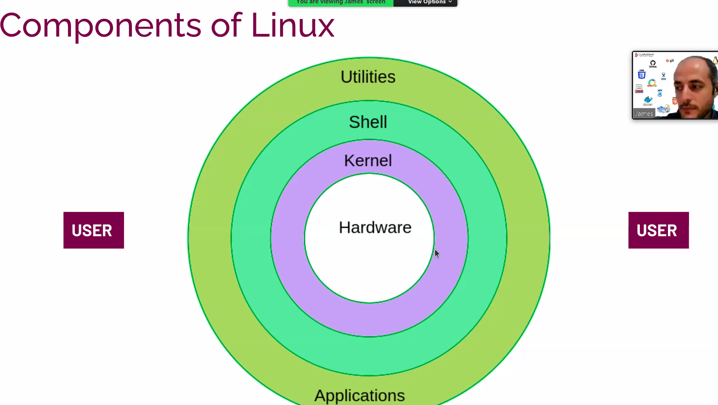

**Linux acik kaynak isletim sistemidir**

**Distributions; linux dagitimlari yapan ayri isletim sistemleridir Linux Kernel i isletim sistemi olarak kullanirlar**

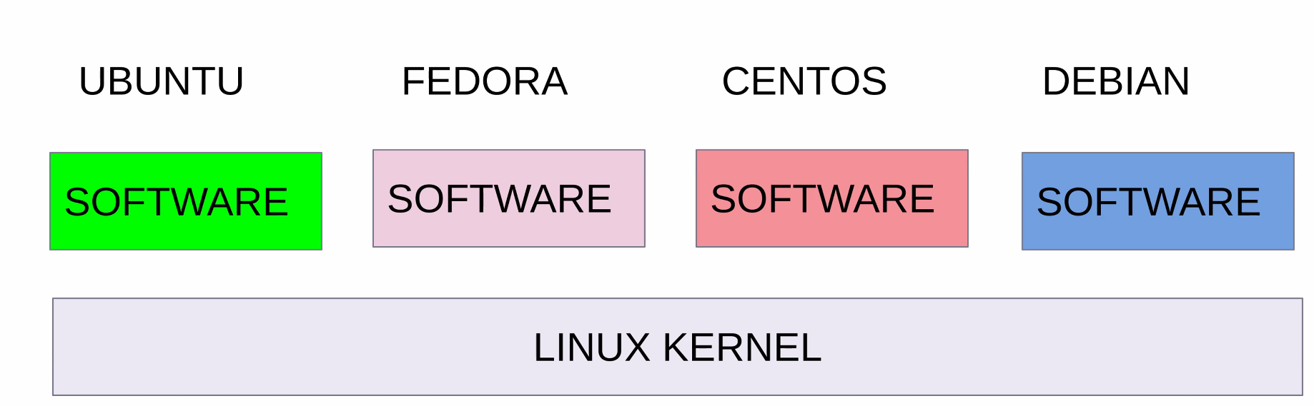

**Linux Kernel bunlari Distribute eder. Temel de linu**

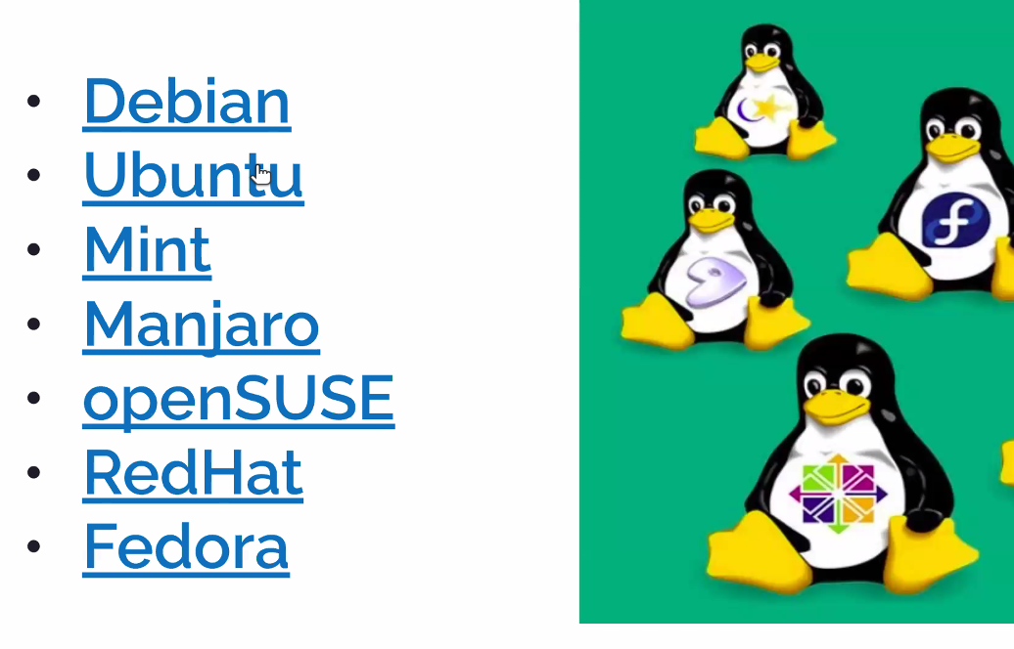

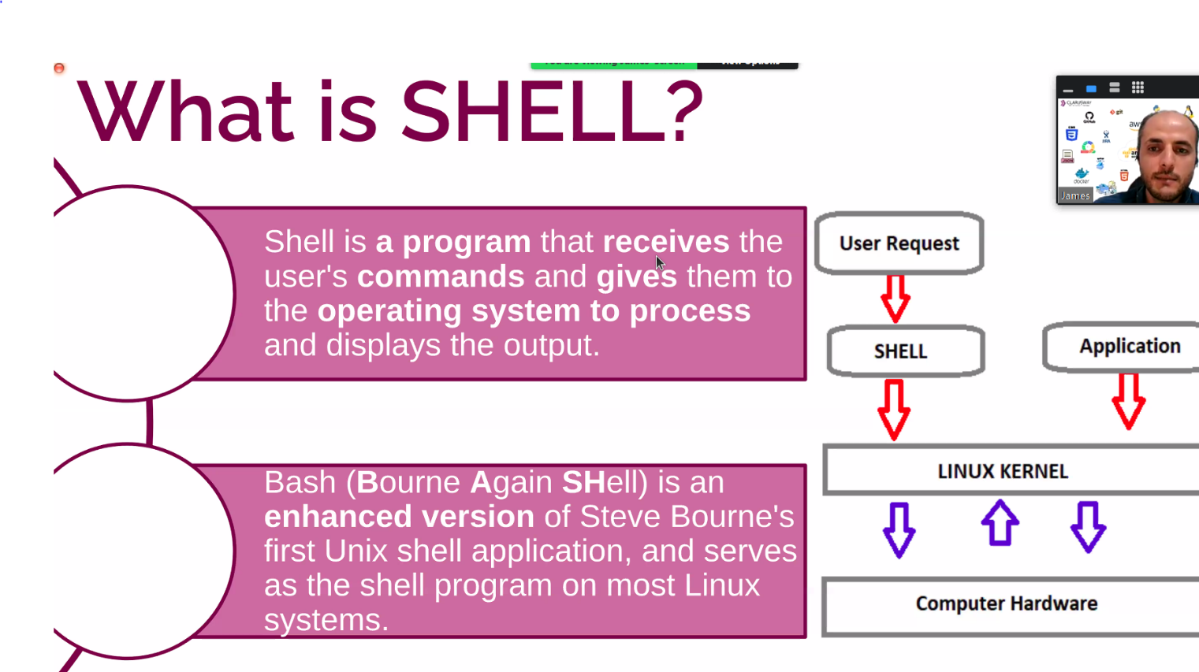

**Kernel ile bizim aramizda getir götur isleri yapar**

**Shell Ayni zamanda bir programlama dilidir**

**¨¨~~ ----------->**

**4**

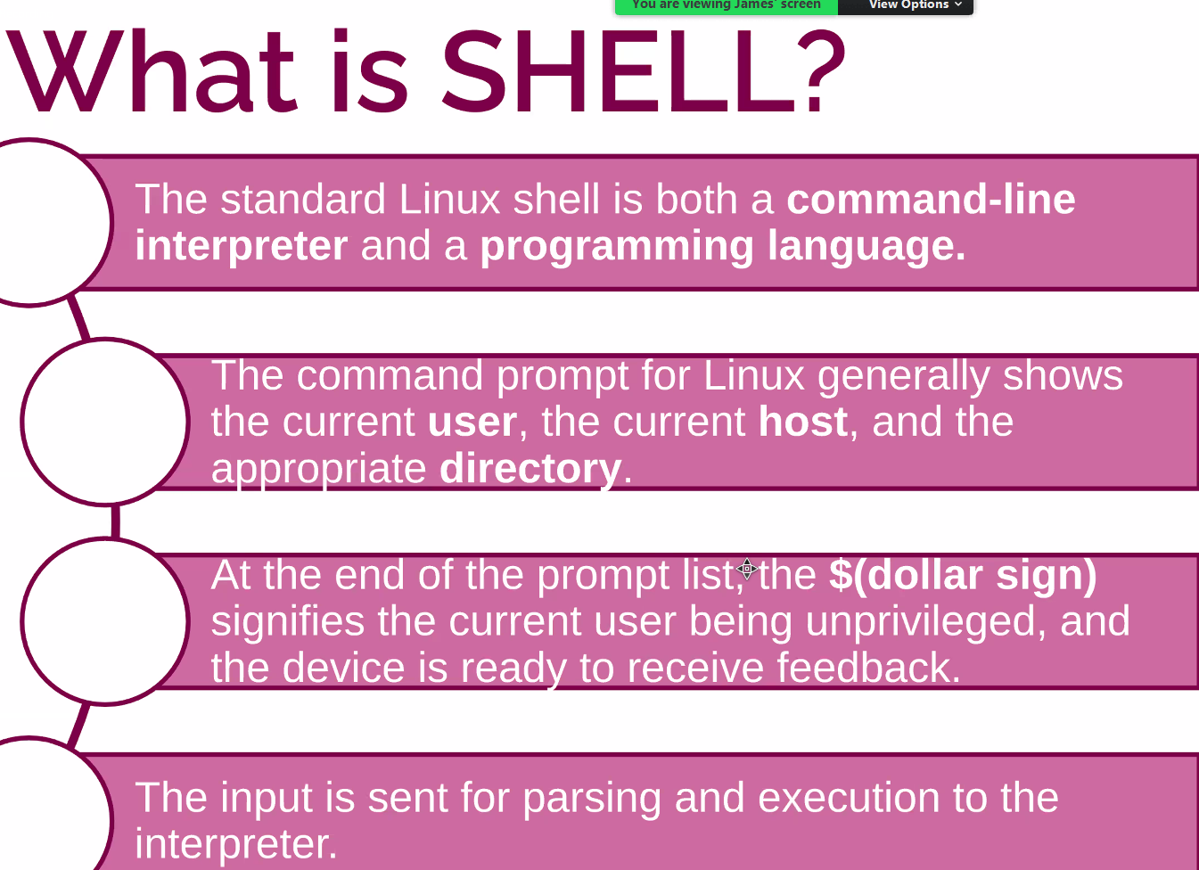

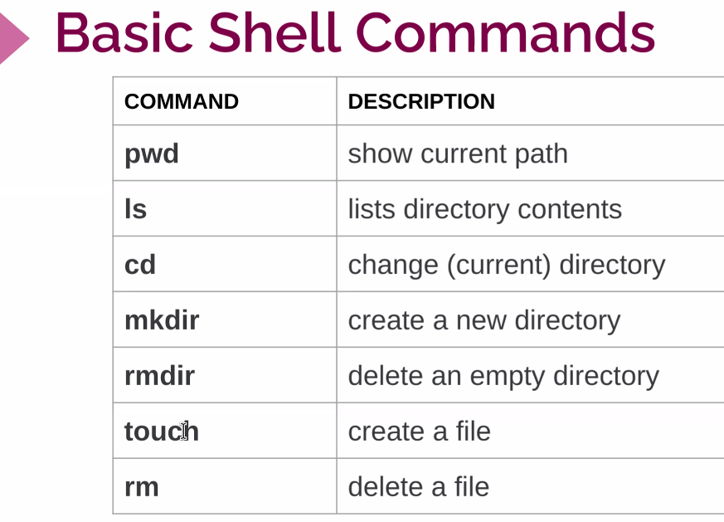

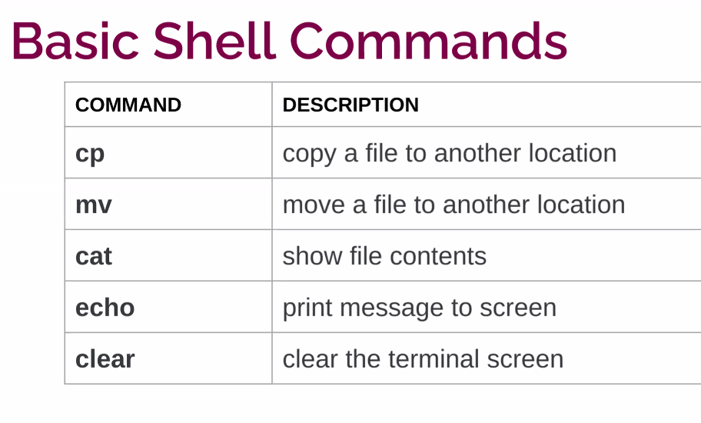

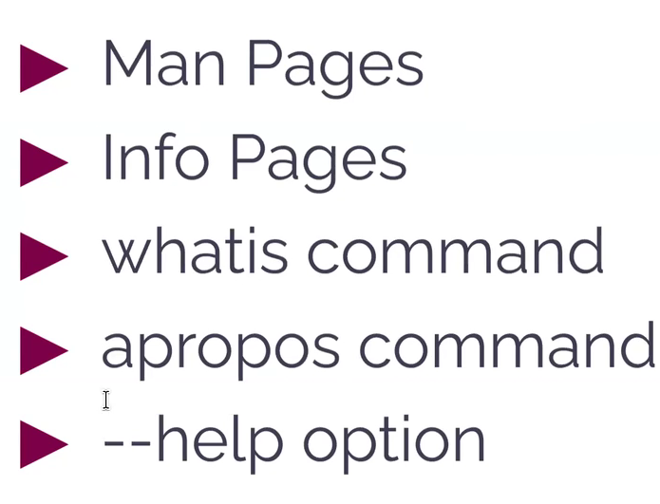

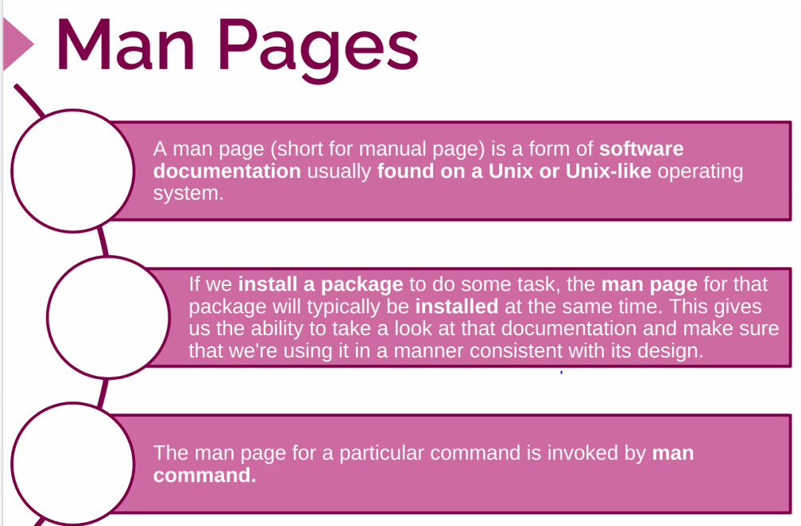

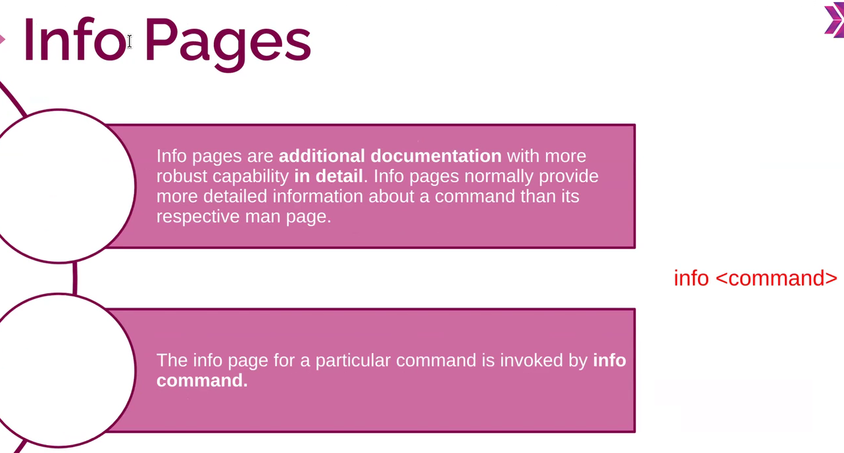

**Komutlarin kullanim klavuzu**

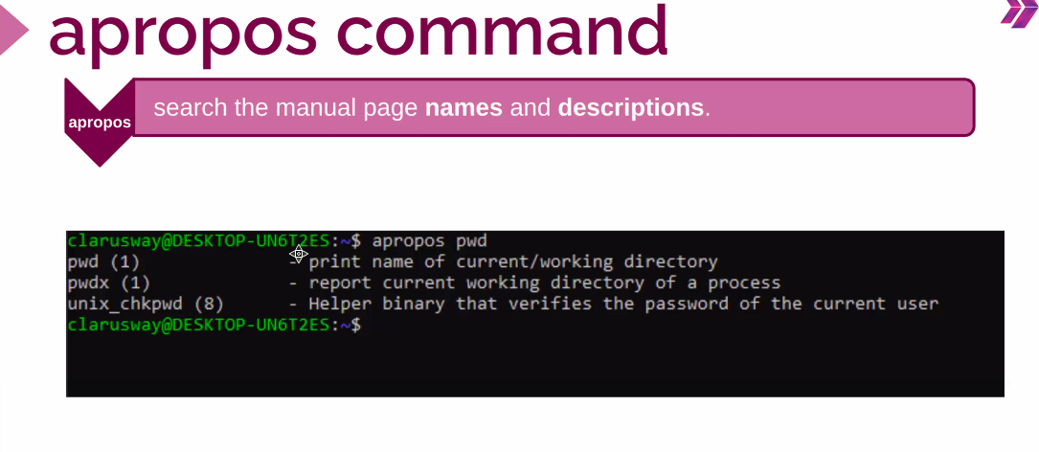

**Komutlarin ne ise yaradigini ögrenmek icin kullaniyoruz**

**Ls --help**

**man ls**

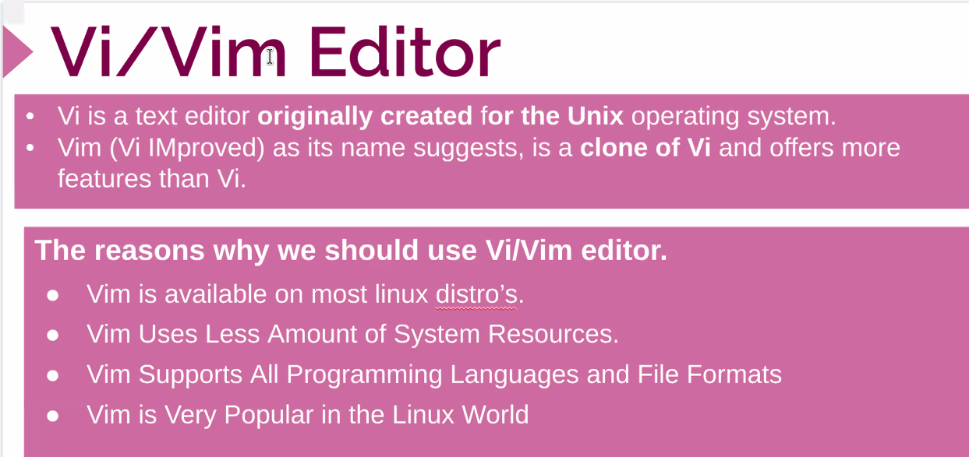

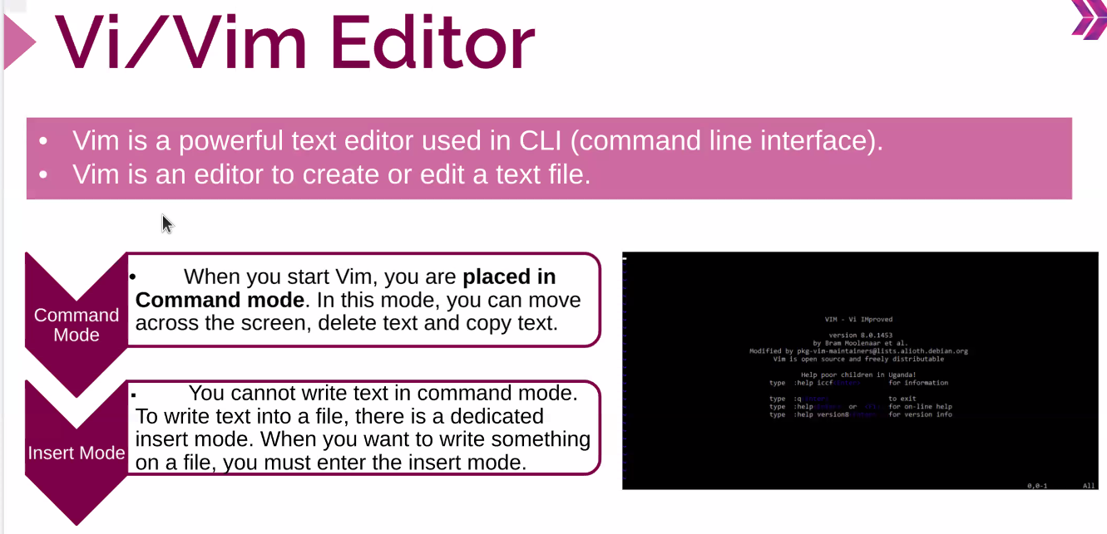

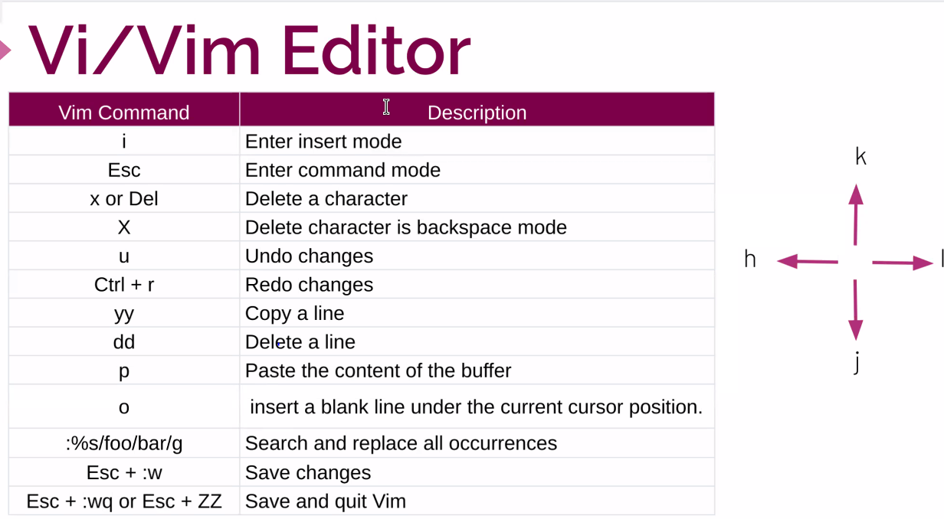

**Ctrl l silmeden yukari gönderir**

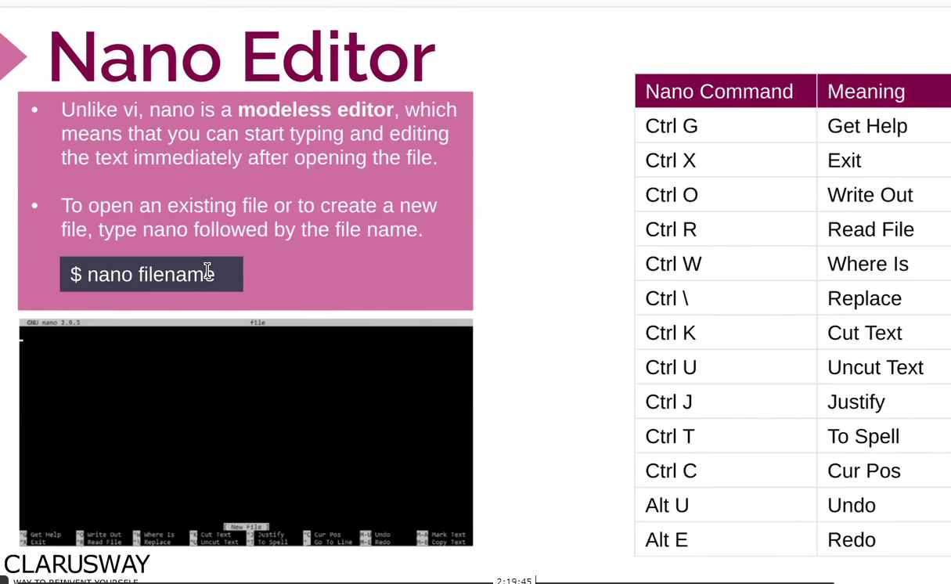

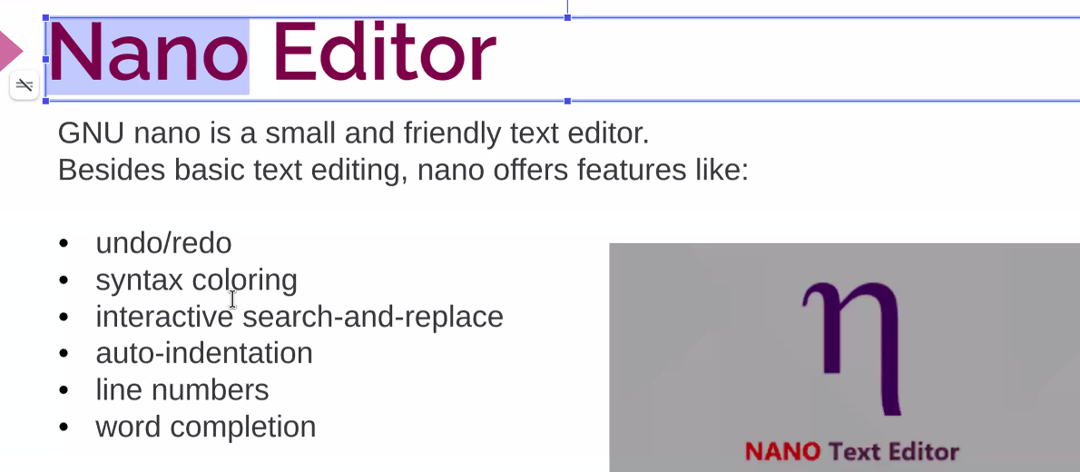

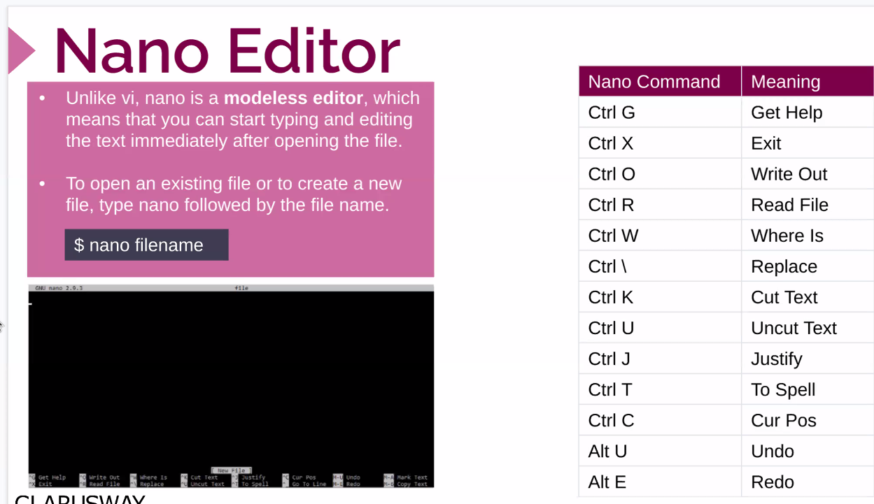

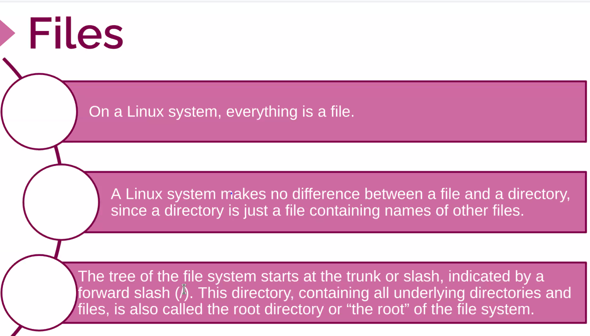

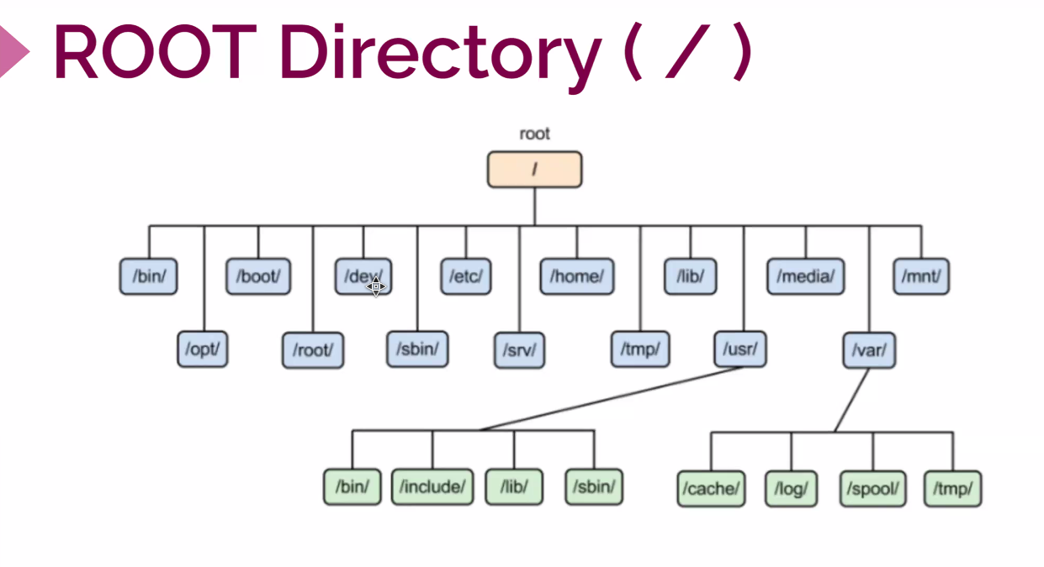

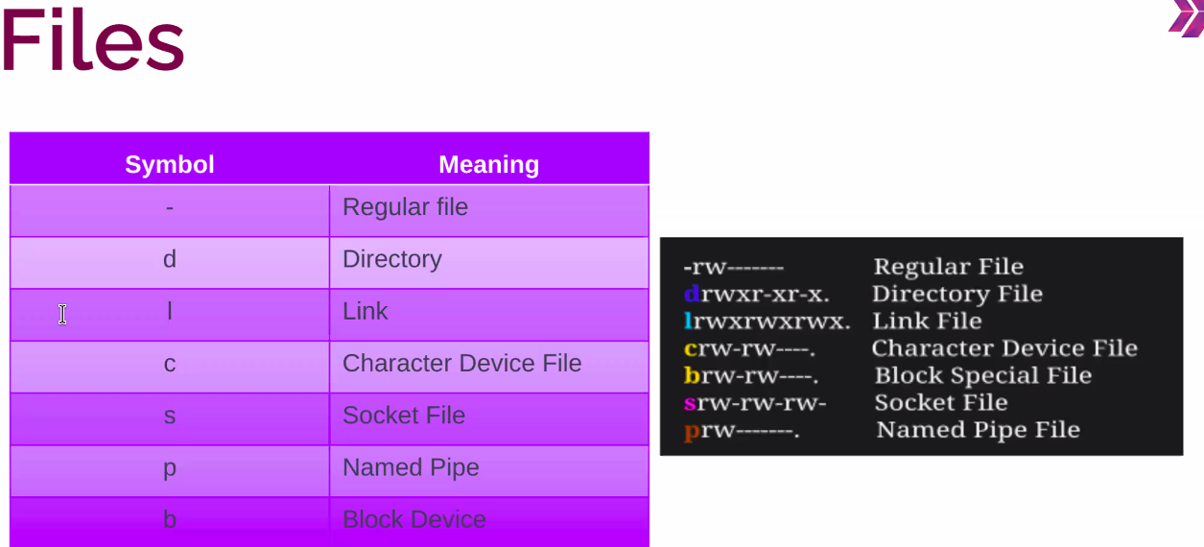

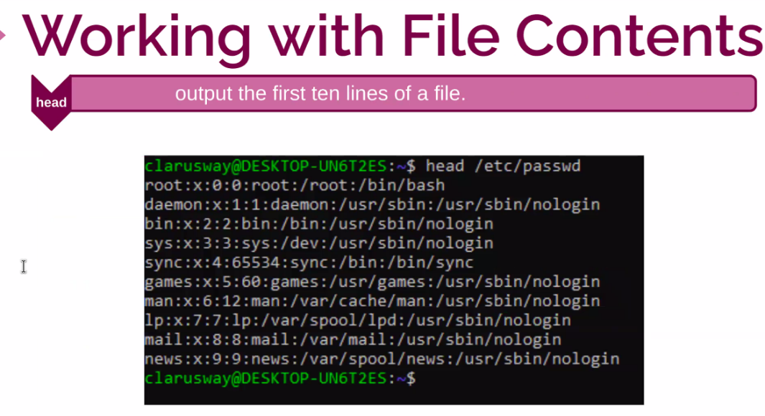

1

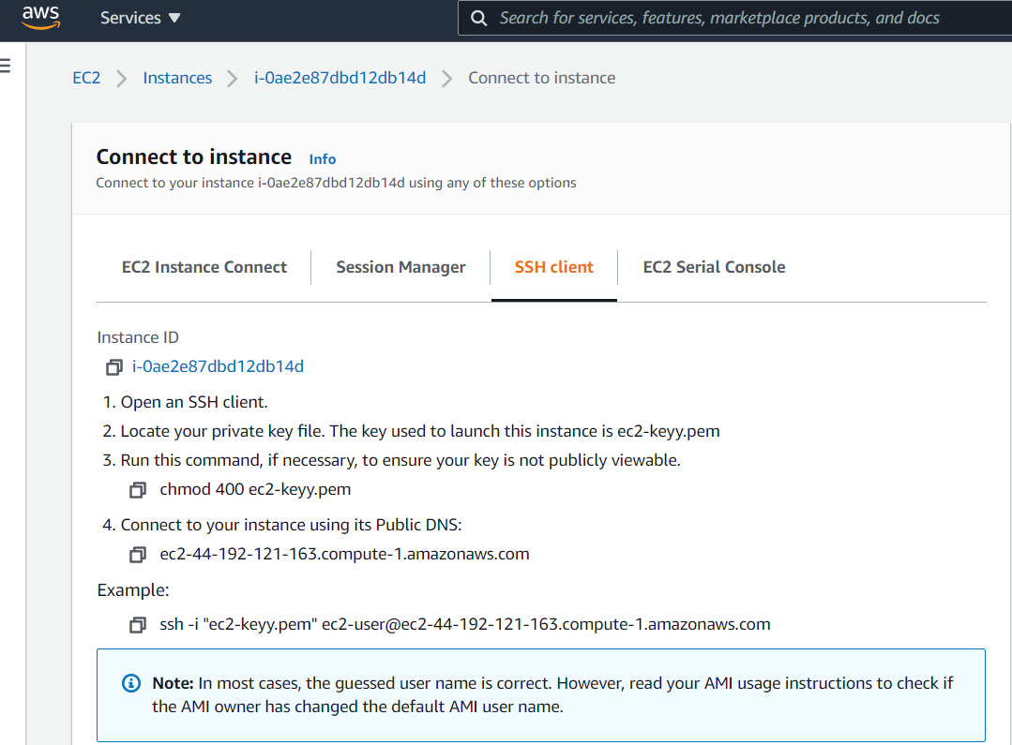

**Adresi Kopyaladik**

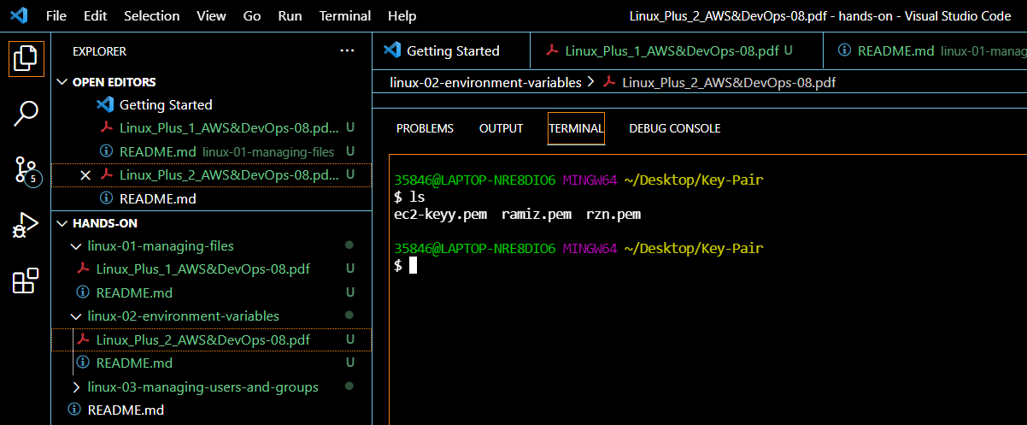

**Key Pair imiizin olduugu yere gelip Adresi buraya kopyaliyoruz ve basliyoruz calismamiza baaliyoruz** A

**Help Komutlari ;**

**man ls ---------------------------> ls komutunun ne anlama geldigi ile ilgili bize bilgi veriyir**

**info ls --------------> daha detay ve ayrinti bululnur**

**Whatis ------------------> tek satirlik aciklama döndurur**

**Apropos pwd ----------> butun pwd yazili**

**Ls --help ----------------------> komut le ilgili bilgi verir**

**Ls -a-------------------> bir ust klasor ile bulundugumuz klasöru göster**

**Ls -A --------------------->**

**Claer-------------------> ekrani temizleriz**

**Ctrl l------------------->ekrani temizlemeden yukari kaydur**

**Vim ;**

**Command modda**

**X -------uzerine geldigimizi siler**

**O------ yeni satir yapar**

**Kopyalama islemi icin insert modda ESC bas , sonra V harfine bas sag oku ile isaretle y ile kopyala o ile yeni satir yap ve command modda p ile yapistir**

**Sift zz -----------> kaydet ve cik**

**:Qw------> kaydet ve cik**

**:Q!-----------> kaydetmeden cik**

**Root directory de degisiklik yapamayiz ancak home directory de yapabiliriz**

**Cd / ------------------------------> root directory ----en baba yere**

**Cd ------------------------------> home directory e göturu**

**Cd home ------------------------>**

**Home directory ---------------------->kendi dosyalarimizin bulundugu dosya**

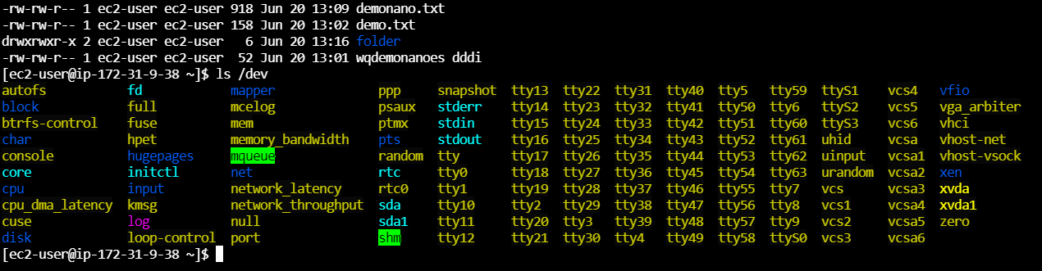

**Maviler Klasör**

**Beyazlar File**

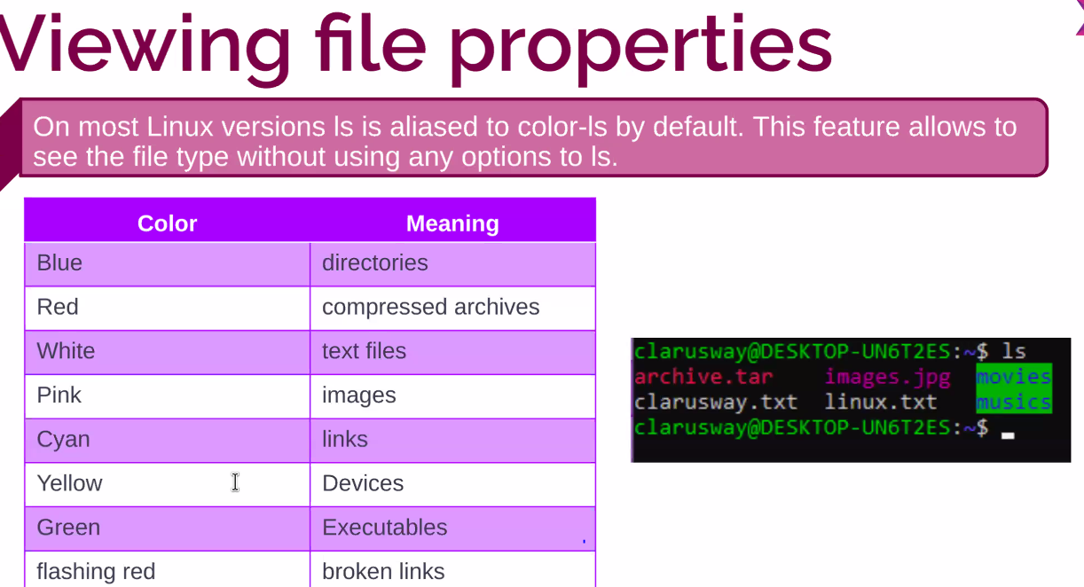

**Temel Linux Komutlari ;**

**Mkdir ---------> create a folder**

**Vim - Nano ------> create a file liked txt,doc,pdf**

**Cat --------> show the inside of the file**

**Haed ------------> show the first ten lines of the files**

**Head -5 file name -----> show only the first 5 lines of te files**

**Tail file name ----------> show the last 10 lines of the files**

**Tail -2 file name ------------> show the last 2 lines of the files**

**Echo "this is file1" > file1 -------create file1 and wrtite this sentence in the file1**

**Echo "this is file1" >> file1 -------> create file1 and don t clear inside of the file and write this sentence**

**Cat -n(number) file name --------> give a number all lines in the file**

**Cat > abc .txt -------------------------> create file and write in this file**

**Abc**

**Def**

**lgh**

**more fıle name ----------> show a part of the fıle if you want to see more of them press the enter**

**Less file name------------> show a part of the file don`t all of them less is tyhe faster than more because dosen´t download all. If you read the big file less is usefull.**

**Tac file name ----------show the reverse of the file**

**Tac file name > the other file name ------> create new file write reverse of the before file**

**Pwd > pwd.txt ----------------> create file name of pwd and file in the pwd**

**Ls > ls .txt -----------------------> create a new file and list in the file**

**History > history.txt**

**Find . Name filename -------------------> find file**

**Find . iname filename -----------> casesensitive find the file big or small letters is not important**

**Find /home iname file name-------> find casesensitive file in the home directory**

**Grep "is" grep.txt------------------> find the is in the grep.txt**

**Man find | grep "size" --------------> find in the man "size " word**

**Man find | less ---------------------> find in the man step by step**